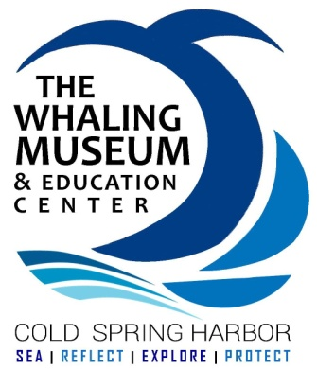
Call for CITs
We invite students from 7th Grade – High School to join our team leading our Camp Weeks at The Whaling Museum. Have fun assisting with our camp activities, earn community service hours along the way, and gain valuable work experience with children!

(insert dates, theme titles, and times they would be expected to work)

Main Function of CIT (Counselor in Training):
- To help facilitate an educational summer camp experience for campers
- To insure a friendly and secure feeling for all children attending camp
- To gain experience with children and running art, science, and environmental programs
Responsibilities:
1. Become familiar with and follow all daily protocol procedures and directions outlined by Education Staff
2. Assist with leading daily camp activities, including science & art-related programs for campers

3. Provide a safe and friendly experience for all children in camp, including:
- Knowing where campers are at all times
- Encouraging enthusiasm during games and activities, and encouraging attentiveness during learning
- Leading & interacting with all the campers in group
- Keeping cell phones on silent and out of sight
- Modeling positive social behavior for students
- Exhibiting professional and courteous behavior to parents
4. Notify Education Staff immediately if there is a health problem or concern regarding a camper.
5. Maintains a professional public profile which supports and promotes volunteer
participation, CSHWM and its goals and mission.

6. Other duties as assigned by Museum Staff.

This position is a non-paying, volunteer CSHWM position. CITs may use their time here towards their community service hours for school-based initiatives. Community service letters will be provided at the conclusion of the summer.

Interested students should contact: ______

